SKILL – 4
PART – A:
1. Open the Amazon S3 Bucket Dashboard
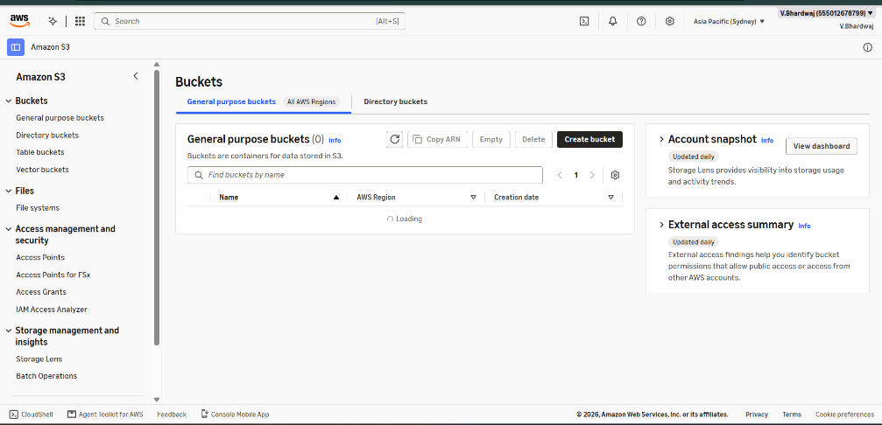
2. Create a New S3 Bucket
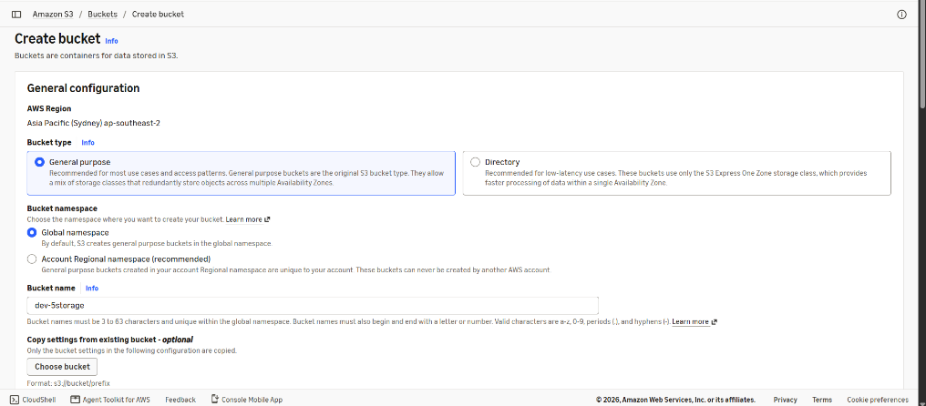
3. Verify the S3 Bucket Creation
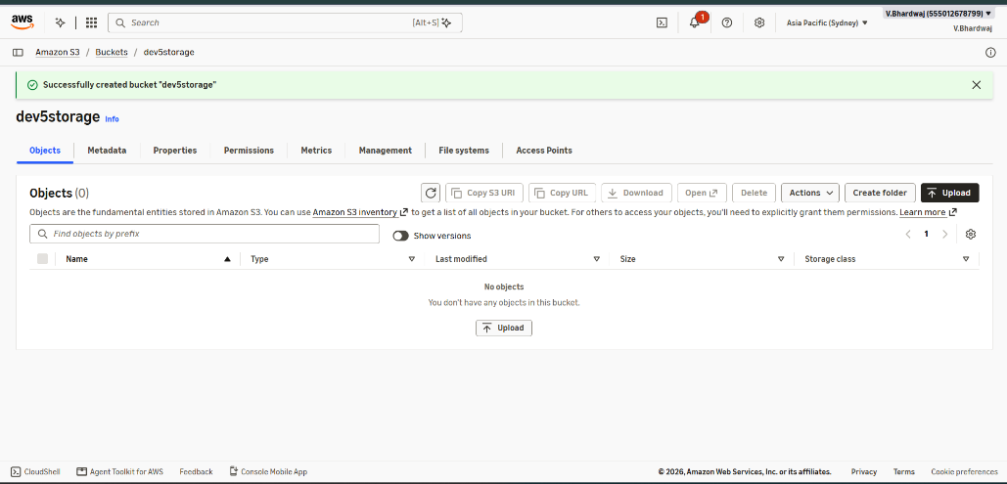
4. Open the Bucket and Select Upload
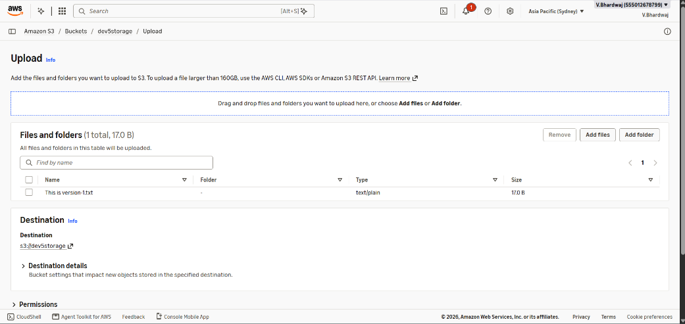
5. Review the Upload Status
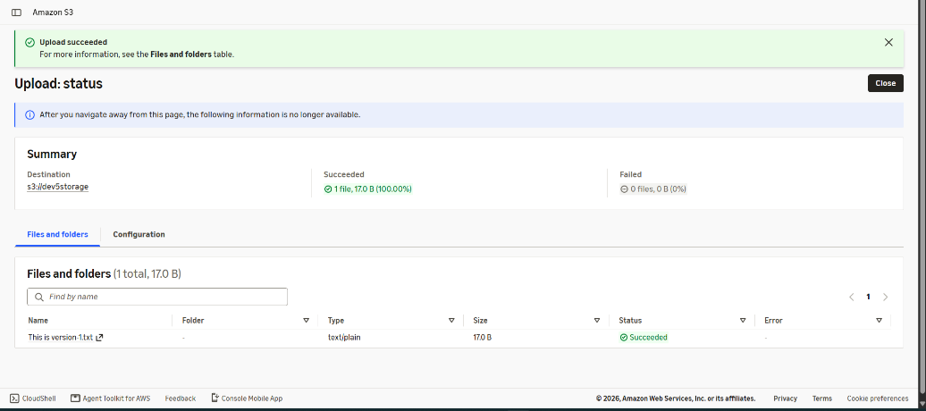
6. Verify the Successful File Upload
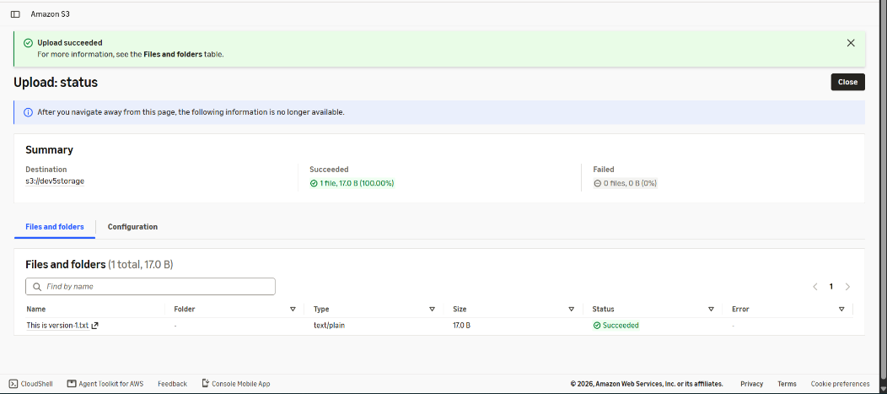
7. Confirm the Uploaded Object in the Bucket
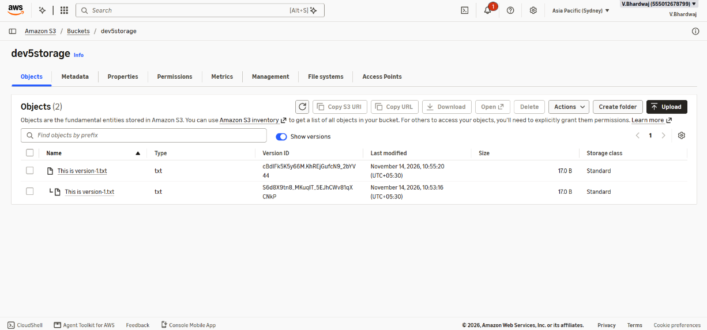
PART – B:
8. View the Objects Stored in the S3 Bucket
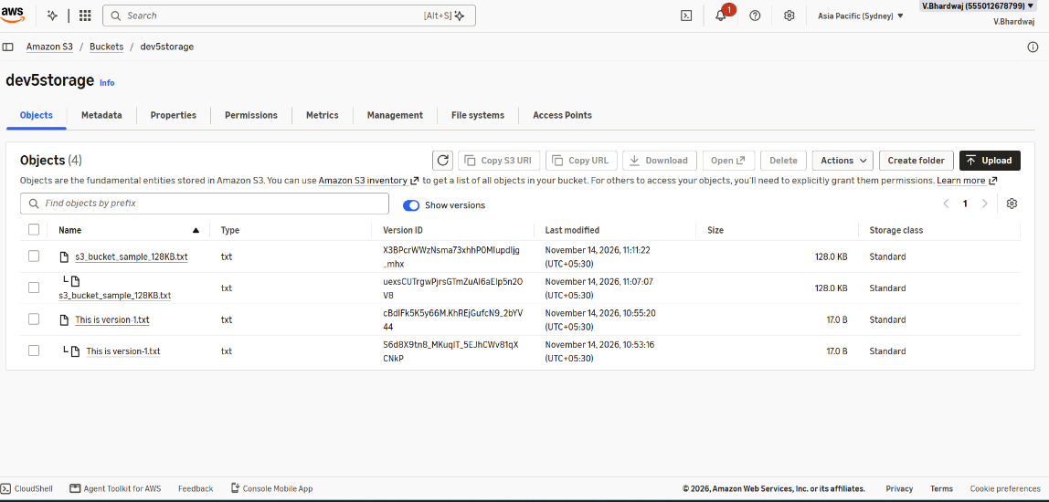
9. Open the Bucket Management Tab
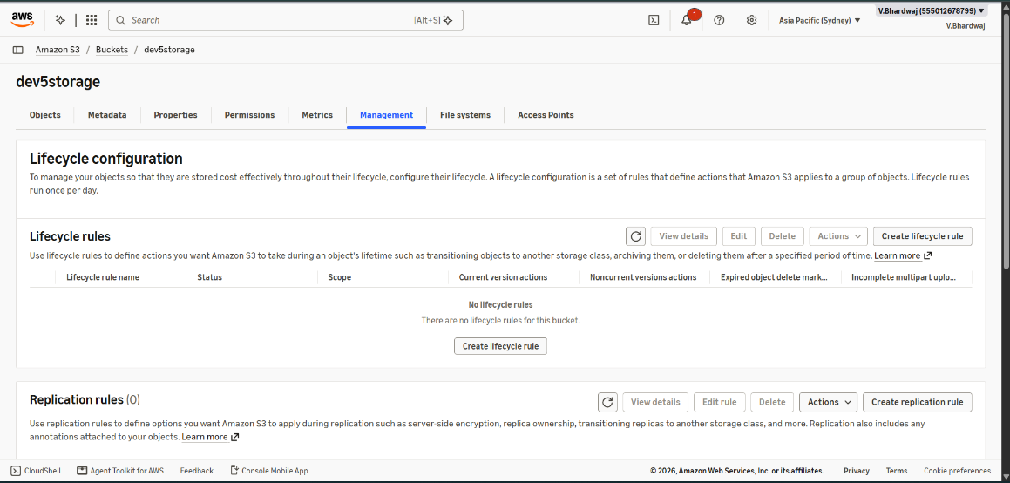
10. Start Creating an S3 Lifecycle Rule
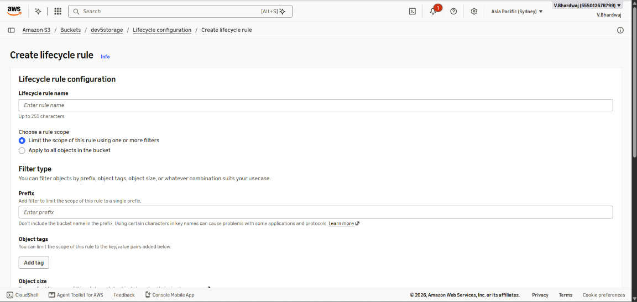
11. Configure Lifecycle Rule Actions and Transitions
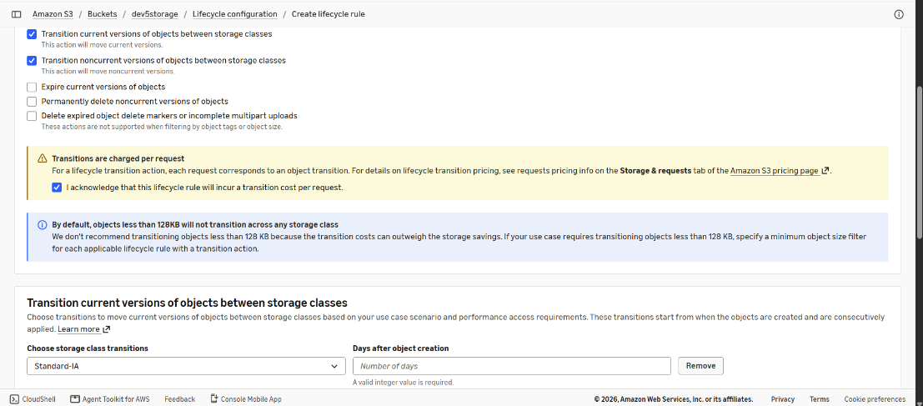
12. Verify the Created Lifecycle Rule


